**Div content wrapper**

# AIFA – Fitness Artificial Intelligence

LOGO

**Navigation**

**Main Section**

ARTICLE

FIGURE

Image map

# HIIT Can Get You Huge, Especially If You Are A Meathead In Need Of Cardio

BLACKQUOTE

The cardio devil details the effectiveness of HIIT cardio, breaking it down to the cellular level. Learn all you need to know about the science of slim.

by [John Kiefer](http://www.bodybuilding.com/fun/other.htm)   
Last updated: Nov 07, 2014

You don't want conventional wisdom. You want to show convention your middle finger and start doing things the right way—and this applies to everything, across the board.

Take fat loss, for example. When you want to reach ridiculously low levels of body fat, what's the first thing conventional wisdom tells you to do? More cardio. The idea, then, is to put in hours and hours of work on the treadmill, elliptical and bike, right? That, conventional wisdom says, is how you'll get the fat off.

As usual, however, science tells us something different. Numerous studies have shown that this sort of steady-state cardio isn't even effective for burning fat. It also tells us something most of us don't know: that there's a big-time downside to doing hours of cardio, and several things to think about the next time you reserve an hour-long block of your time to step on a treadmill.

### Drawbacks Galore

When you perform conventional cardio for long periods of time, it's been found to deteriorate muscle tissue and decrease testosterone levels. That's bad, obviously, but things get even worse. A recent study in [*The American Journal of Physiology*](http://www.physiology.org/) found that steady-state cardio decreases the ability of muscles to absorb glucose after training.

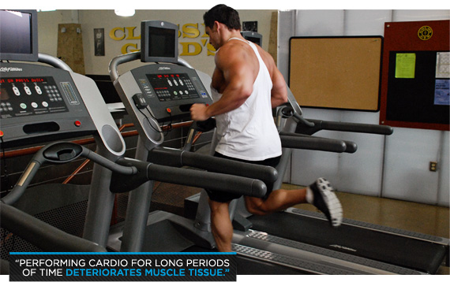

This happens because cardio immobilizes the GLUT4 transport system, which is responsible for the insulin-regulated translocation of glucose into cells. Cardio further limits hypertrophy by shutting down the mTOR pathway, which is one of the primary regulators of muscle growth. When this happens, you burn the same amount of muscle as you do fat.

All isn't lost though. It's possible to avoid all of this by doing things in a different way. It's even possible to make your cardio anabolic [promoting constructive metabolism].

### Ramp It Up

The "right" brand of cardio for anabolic fat loss is [High Intensity Interval Training (HIIT)](http://www.bodybuilding.com/fun/high-intensity-interval-training-the-ultimate-guide.html). This consists, in practice, of a set of bursts of balls-out, massive output cardio work followed by timed rest periods. This type of cardio is similar to the Fartlek style favored by old-school track athletes and it's been around for years, but it has enjoyed resurgence with this everything-old-is-new-again movement so prevalent in today's fitness industry. It's a simple concept, however, and since we know a lot more about how to program it—in terms of volume, intensity and duration—it's a perfect solution for anyone looking to drop fat.

It's all backed up by plenty of research, too. The [*Journal of Strength and Conditioning Research*](http://journals.lww.com/nsca-jscr/pages/default.aspx) published recent work showing that HIIT can actually increase testosterone levels and GLUT4 concentration. Steady-state cardio, as I wrote earlier, has the exact opposite effect. Research has also shown that HIIT increases 24-hour mitochondrial biogenesis. This is the formation of new energy-producing mitochondria in cells, a process that typically shuts down mTOR during steady-state cardio.

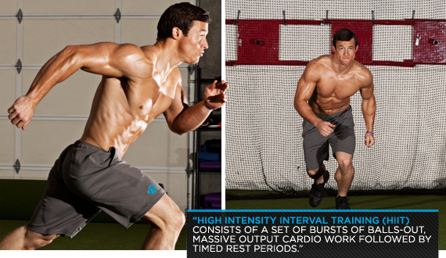

Last, but not least, HIIT sets off an increase in the concentration of myofibrillar nuclei. Hypertrophy depends on increases in this concentration, along with the content of your muscle fibers.

### Start The Countdown

When it comes to the fat-burning process, timing is everything. The good news for you, however, is that if you decide to make HIIT your primary form of cardio, there are several tweaks you can throw in to enhance the process and get the fat off much faster.

The first of these tweaks applies to how you space out your workouts. Make sure to schedule your training so that you complete your HIIT sessions up to an hour before you train with weights. Studies have shown that when you time this properly, it can amplify the aforementioned mitochondrial biogenesis. Research in the [*Journal of Applied Physiology*](http://jap.physiology.org/) also showed that scheduling your training sessions this way also turns on the mTOR pathway of growth instead of shutting it off—the benefits of which were explained earlier.

Volume is the other key consideration with HIIT. Research has shown that higher-rep, strength-endurance training is the most effective way to complement your HIIT sessions when you perform both on the same day.

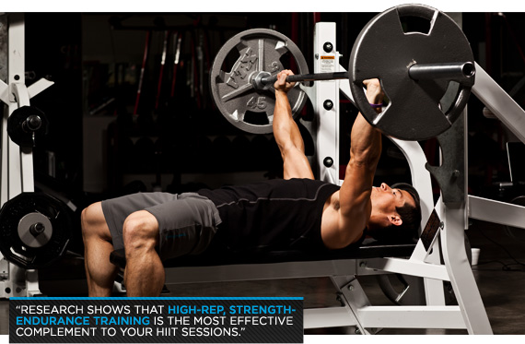

Finally, you'll want to cycle everything. With HIIT, it's most effective to go four weeks on, followed by four weeks without it. During your HIIT-less cycle, focus strictly on hypertrophy to promote mitochondrial biogenesis and an increase in the nuclei effect. When your nuclei density is greater, you can make your muscle fibers larger. The only way to increase the number of intracellular nuclei you have, however, is to perform strength-endurance training.

This is somewhat dichotomous because this type of training will actually make muscle smaller. That's how it works: to get more nuclei to get bigger, you have to begin by training to make a muscle smaller. This sounds counterintuitive, but it works.

### Time To Grow

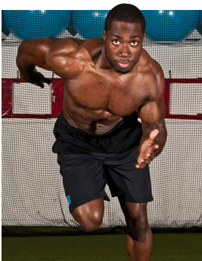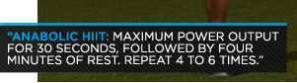

When you're done with your strength-endurance cycle, you'll be left with an increased number of cellular nuclei. Then, once you start a strict hypertrophy schedule, you'll be able to get bigger than you otherwise could have.

It's possible to lose some mitochondrial density here—this makes muscle oxidative—but it takes much longer to actually lose the mitochondria. Simply put, you alternate between periods of increasing your potential to gain muscle (your "on" HIIT weeks), and periods where you actually fulfill that potential and get bigger and stronger (your "off hypertrophy cycle).

HIIT can be performed a number of different ways, but to make things as anabolic as possible the idea is to get as close as you can to maximum power output for 30 seconds, followed by four minutes of rest, for four to-six rotations.

For your week "on" cycle, you'll follow this pattern three times each week. I like using spin bikes—the ones in your gym's aerobics room—for this. Don't focus on speed here. Instead, increase your resistance and your rate of force production .This lower cadence will give you greater surge of testosterone—probably because it simulates a form of resistance training.

### Supplementation

To get this right, there's a bit of supplementation you'll need to complement your HIIT cycles. I've long been known as a huge advocate of adding [leucine](http://www.bodybuilding.com/store/lleucine.html) to any supplement plan, and in terms of HIIT, I believe it's especially effective. Here, I'd recommend taking at least five grams of it before your workouts.

Research in the [*American Journal of Clinical Nutrition*](http://ajcn.nutrition.org/) showed that taking leucine-enriched amino acids before aerobic exercise can increase post-exertion protein synthesis by up to 33 percent—further proof of leucine's efficacy.

*Reprinted with permission from the Nov/Dec 2012 edition of* [*Power Magazine*](http://www.thepowermagazine.com)*.*

ASIDE

SECTION

FIGURE

Image map

FIGCAPTION

### 7 Creative Hacks To Improve Classic Exercises

SECTION

FIGURE

Loss-ingredients.jpg

#### 5 ingredients for the perfect fat loss circuit

Too often, metabolic circuits are little more than a mess of randomly paired movements. Here's the formula for a precise fat-loss workout that will test your limits while providing results!

SECTION

FIGURE

Image map

#### [Gym Hacks You Need To Know](http://www.bodybuilding.com/fun/7-gym-hacks-you-need-to-know.html)

Think outside the box, and your reward will be a better, more efficient workout. Use these 'hacks' to your advantage to become the envy of the weight room

SECTION

FIGURE

Burn-fat-like-crazy.jpg

#### [Burn Fat Like Crazy With 3 Unconventional Cardio Styles!](http://www.bodybuilding.com/fun/burn-fat-like-crazy-with-3-unconventional-cardio-styles.html)

Traditional cardio can be boring, unproductive cardio. Stop walking the treadmill like a zombie and try these alternative workouts that scorch fat and build strength!

SECTION

FIGURE

Hit.jpg

#### [HIIT Can Get You Huge, Especially If You Are A Meathead!](http://www.bodybuilding.com/fun/hiit-can-get-you-huge-especially-if-you-are-meathead.html)

The cardio devil details the effectiveness of HIIT cardio, breaking it down to the cellular level. Learn all you need to know about the science of slim.

SECTION

FIGURE

Mistakes-back.png

#### 5 Mistakes Holding Back Your Gains

Don't let your muscle growth be limited by gains-killing mistakes. Easily dodge these 5 common roadblocks with MVP tips from the Twinlab Muscle Militia!

SECTION

FIGURE

Compound-exercise-pic1.png

#### [Compound Exercises Bring Compounded Results: Get More In Less Time!](http://www.bodybuilding.com/fun/powerful_workout_exercises.htm)

Yes, it is possible to get a superior workout - without spending hours in the gym. Make the most of your time by building a routine using these tried and true compound exercises today! Learn more.

SECTION

FIGURE

Image map

#### [Smart Dumbbell Lifting: Iso-Dynamic Training](http://www.bodybuilding.com/fun/smart-dumbbell-lifting-iso-dynamic-training.html)

Isometric training can be difficult and tedious, but you can reap its benefits with this overload technique. Pick up two dumbbells and start moving one of them!

SECTION

FIGURE

Hit.jpg

#### 5 keys to doing high-intensity intervals the right way

Cardio may be boring, but at least you'll burn far more calories when you follow these 5 rules for making HIIT workouts vastly more effective.